SnapUp Banner 1 — Smart Scanning
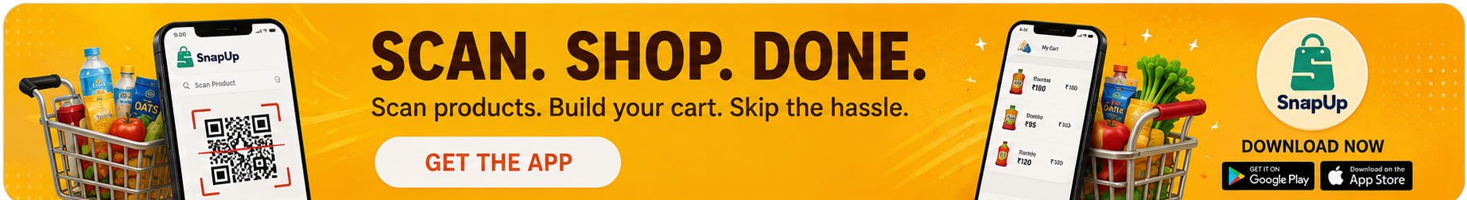
SnapUp Banner 2 — Supermarket Savings
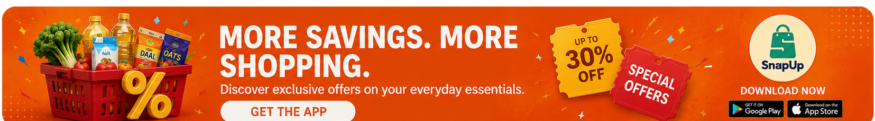
SnapUp Banner 3 — Simplified Shopping
